
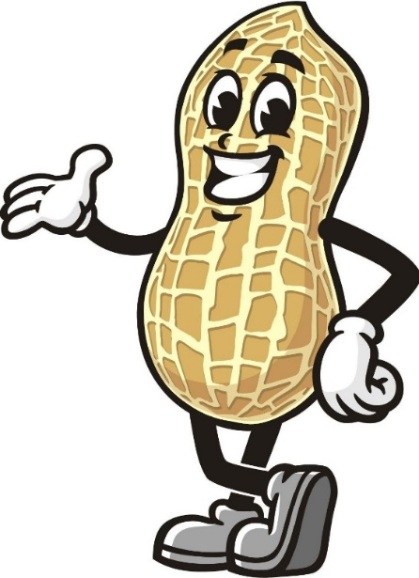
Mixed Nuts

Tonight at 6:30 p.m. April 11, 2024
Get ready for a journey through the golden era with our set of big band hits from yesteryear featuring Nat King Cole.

Mixed Nuts

Tonight at 6:30 p.m. April 11, 2024
Get ready for a journey through the golden era with our set of big band hits from yesteryear featuring Nat King Cole.

